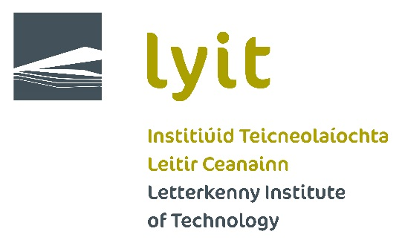

Enabling Mathematics Course

A joint initiative by Letterkenny Institute of Technology and
Donegal Education and Training Board

September 2021

Background
The enabling course in mathematics is a joint initiative between Donegal Education and Training Board and Letterkenny Institute of Technology arising from the signing of a formal memorandum of understanding between LYIT and DETB in January 2016. The overall objective of this partnership is to provide for enhanced progression opportunities and pathways for learners consistent with the Further Education and Training Strategy, 2014-2019 and the National Strategy for Higher Education to 2030. It is in direct response to the impediments to access to higher education arising from the number of students not passing mathematics at leaving certificate and therefore failing to meet the minimum entry requirements for programmes. The development of this Enabling Course in Mathematics is designed to give young people a second chance to succeed in Mathematics and thus, overcome the entry requirements to enter a wide range of courses in 2021.
Enabling Mathematics Course
- Course will commence on Tuesday 7th September until Friday 17th September 2021. Timetable below.
- Classes for the Enabling Mathematics Course will be held in LYIT.
- The final examination will be of an equivalent standard to the current leaving certificate ordinary mathematics paper and will be set and assessed by mathematics teachers nominated by Donegal ETB.
- Applicants who are otherwise eligible but lack a pass in ordinary and higher level Maths are the primary target group.
- Students passing the Enabling Mathematics Course will be eligible for a place on any programme in LYIT for which there are “available places”. The list of LYIT’s ‘Available Places’ is published on www.cao.ie and changes on a daily basis.
- From 2021, this alternative entry route and limitations that apply to it will be published in advance.
- In all cases applicants must meet the minimum entry requirements (see www.lyit.ie/full-timecourses/ for details) and the current CAO points for the relevant programme.
- There will be 5 strands to the programme aligned with the Ordinary Level Leaving Certificate Syllabus.

Strand 1: Statistics and Probability
Strand 2: Geometry and Trigonometry
Strand 3: Number
Strand 4: Algebra
Strand 5: Functions
Each of the strands will be followed by a rigorous assessment

- Successful students will be required to participate in on-going maths support throughout year 1 delivered by the Maths Learning Centre in LYIT

Draft Timetable
Draft Enabling Maths Timetable – Week 1 (7th – 10th September)

Time | Tuesday | Wednesday | Thursday | Friday
09.30 –  12.30 | Strand 3  Number | Strand 3  Number | Strand 4  Algebra | Strand 4  Algebra
12.30 – 1.00 | Break | Break | Break | Break
1.00 – 4.00 | Strand 3  Number | Strand 3  Number | Strand 4  Algebra | Strand 4  Algebra
4.00 – 5.00 |  | Assessment |  | Assessment

Enabling Maths Timetable – Week 2 (13st – 17th September)

Time | Monday | Tuesday | Wednesday | Thursday | Friday
09.30 –  12.30 | Strand 5  Functions | Strand 2  Geometry & Trig | Strand 2  Geometry & Trig | Strand 1  Stats & Probability | Strand 1  Stats & Probability
12.30 – 1.00 | Break | Break | Break | Break | Break
1.00 – 4.00 | Strand 5  Functions | Strand 2  Geometry & Trig | Strand 2  Geometry & Trig | Strand 1  Stats & Probability | Strand 1  Stats & Probability
4.00 – 5.00 | Assessment |  | Assessment |  | Assessment

How to Apply
- Contact the Curve – Anne.brennan@lyit.ie or 074-918 6175
- Closing date for applications is Monday 6th September
- There will be no course fee for students
Please bring Pen, Paper, and Calculator. Notes will be provided.

