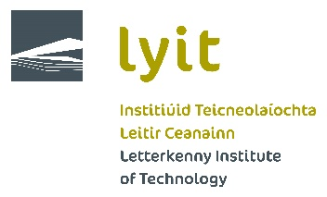

Bank Details Form

To receive your refund please complete all details below and return this form to Admissions (Admissions@lyit.ie) or drop into the Registry Office.

Please ensure you enter account number as per your BANK STATEMENT and not on your Bank Card.

Student ID or CAO Number

Student Name

Home Address

Address at College (if different to above)

Course Name

Year of Course

Bank Name
BIC Number.  (Bank Identity Code Number) | 8 characters
IBAN Number.  (Please enter Number clearly and carefully) | 22 Characters  I E
Date
Signature

Foirm Maidir Le Sonraí Bainc

Ionas gur féidir leat d’aisíocaíocht a fháil, líon isteach na sonraí uille thíos agus cuir ar ais an fhoirm seo chuig go Chlárlann. (Admissions@lyit.ie)

Cinntigh le do thoil go gcuireann tú isteach d’uimhir chuntais ar do RÁITEAS BAINC agus ní ar do Chárta Bainc.

Cárta Aitheantais Nó

Uimhir CAO Mic Léinn

Ainm Mic Léinn

Seoladh Baile

Seoladh Sa Choláiste

Ainm an Chúrsa

Bliain An Chúrsa

Ainm an Bhainc
Uimh. BIC
Uimh. IBAN | I E
Dáta

Síníu

