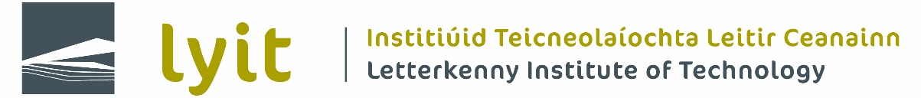

LETTERKENNY INSTITUTE OF TECHNOLOGY
APPLICATION FORM FOR FINANCIAL SUPPORT 2020/2021 (Form A)

PERSONAL DETAILS

Student ID ________________________

Name: ______________________________________________________________

Gender: Male □ Female □ D.O.B.

Address:
_________________________________________________________________________________________

Contact Telephone number: ________________________

Course Title: ___________________________________________ Year: ________________________

Are you or your parents medical card holders? Yes □ No □

Are you in receipt of SUSI Yes □ No □

Did you receive the Students Assistance Fund previously? Yes □ No □

- A complete guide for students is available at www.studentfinance.ie .
- Please refer to ESF data protection regulations regarding possible sharing of your data.

BANK DETAILS

IBAN:

BIC:

Please submit proof of your bank account, e.g. statement or bank letter with the number of your account

Privacy Notice
LYIT values your privacy and recognises the need to process your personal data in a fair, transparent and lawful manner in accordance with the legal obligations as set out in the General Data Protection Regulation (GDPR) and the Irish Data Protection Act 2018.
LYIT’s detailed student privacy statement is available at www.lyit.ie/Student-Hub/Administration-Services/Data-Protection

Please state why you are seeking assistance:
_________________________________________________________________________________________

_________________________________________________________________________________________

Please demonstrate financial support required per month:

Monthly Income | Amount | Monthly Expenditure | Amount
Grant |  | Rent
Parents |  | Travel
Part time Job |  | Food
Other |  | Books
 |  | Bills
 |  | Childcare
Total Income |  | Total Expenditure
Different between both:
Therefore total applied for is:

Financial documentation in support of your application may include:

Letter from landlord stating how much rent you are paying/rent book
Oil/coal receipts
ESB, Phone receipts
Food receipts, Book receipts, Travel, e.g. petrol/diesel receipts or bus tickets
Medical or childcare bills

The Student Assistance Fund is co-funded by the Irish Government and the European Social Fund under Ireland’s European Structural & Investment Funds Programme 2014-2021.

Declaration: I declare that all the information given is true, complete and accurate. Assistance from other sources has not been received for the stated purpose/service, which is the subject of this application.

SIGNED: ______________________________________ Date of Application: _________________

Send completed applications to thecurve@lyit.ie

Decision on SAF application: Approved □ Not approved □

________________________ __________________________ ________________________
Brian Mc Gonagle Fr. Liam Boyle Welfare Officer, SU

